Aquí creamos una base de datos vacía que usaremos para esta práctica
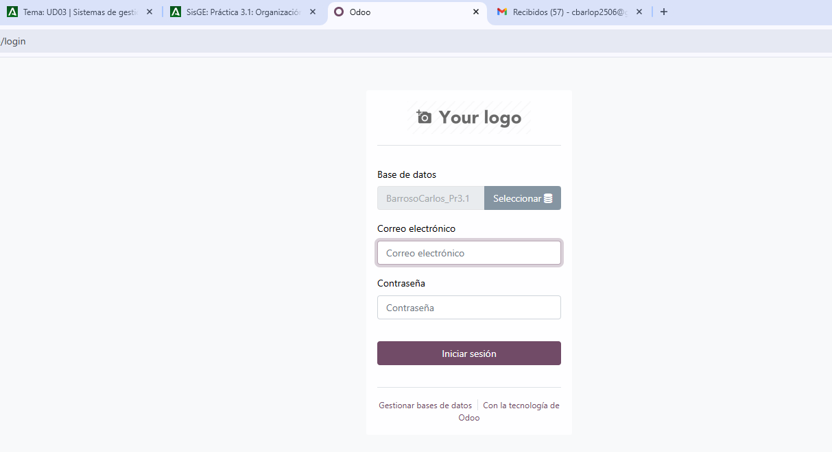
Cbarlop2506@gmail.com 1234

Usamos la copia (back-up) que hicimos en la tarea anterior para hacer una futura comprobación con la base de datos creada anteriormente
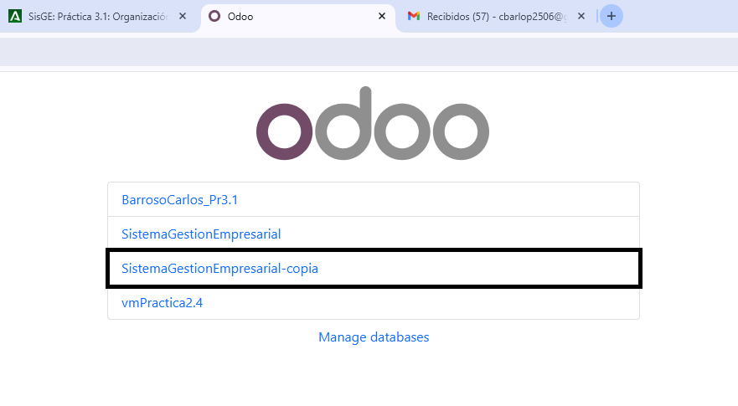
Carlosbarroso2506@gmail.com 1234

Entramos en la base de datos nueva, activamos el modo desarrollador y consultamos el modelo de datos aquí vemos que solo tendría dos campos
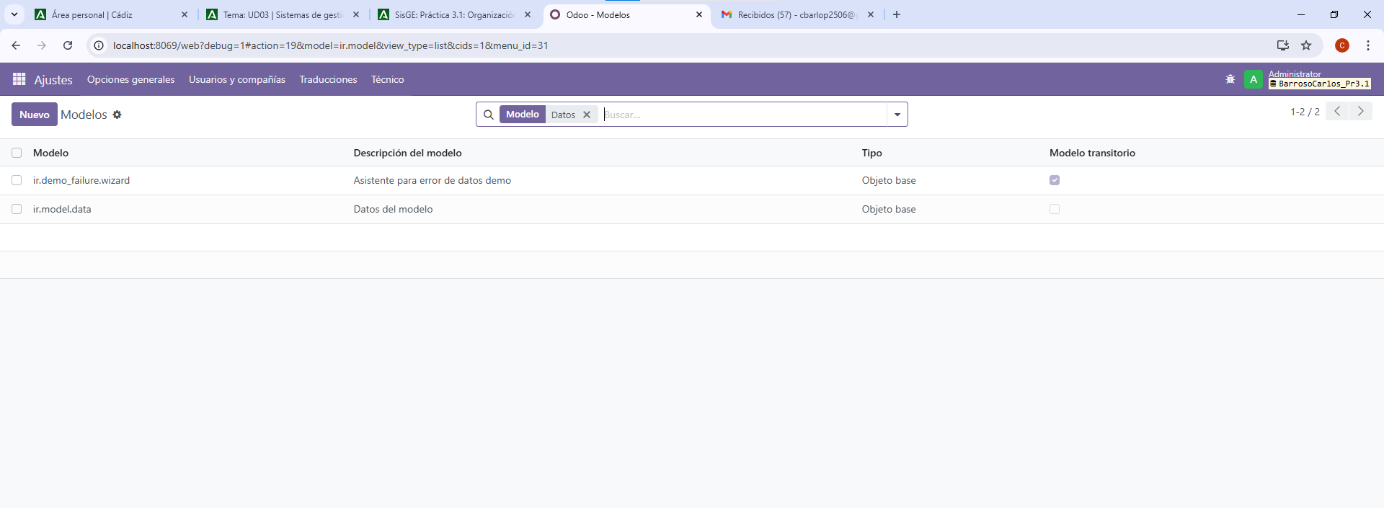

Aquí entramos también en modo desarrollador en la base de datos del backup y vemos que esta que tiene datos y demás almacenados tiene más campos
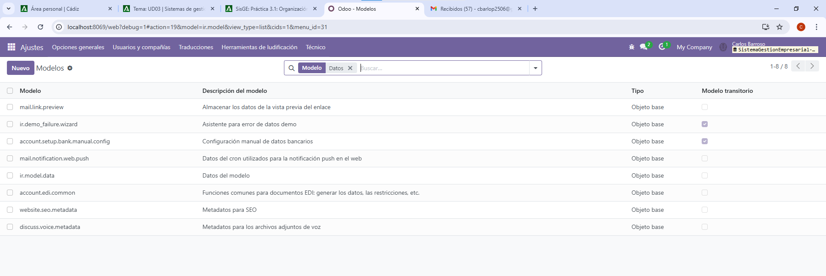

Desde pgAdmin consultamos las tablas asociadas que hemos podido observar en la captura anterior, aquí podemos ver que la base de datos de la taberna de moe tiene mas de 25000 campo y en la que hemos creado vacía tiene apenas unos 6000 campos, podemos comprobar obviamente que ambas bases de datos no tienen los mismo campos.
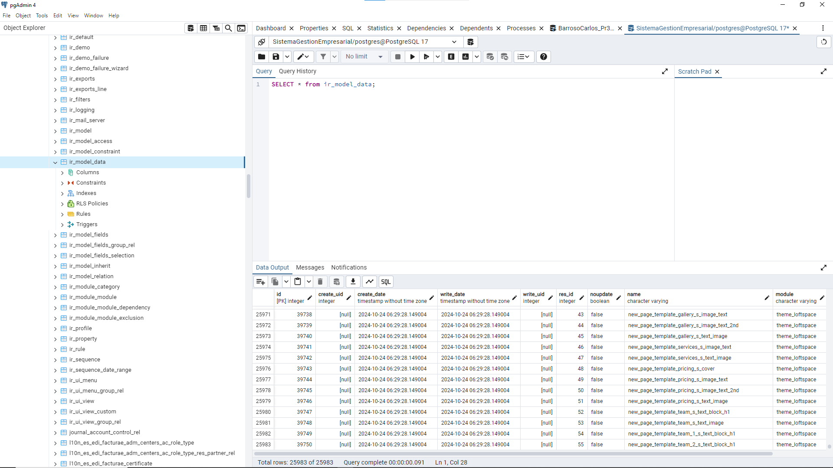

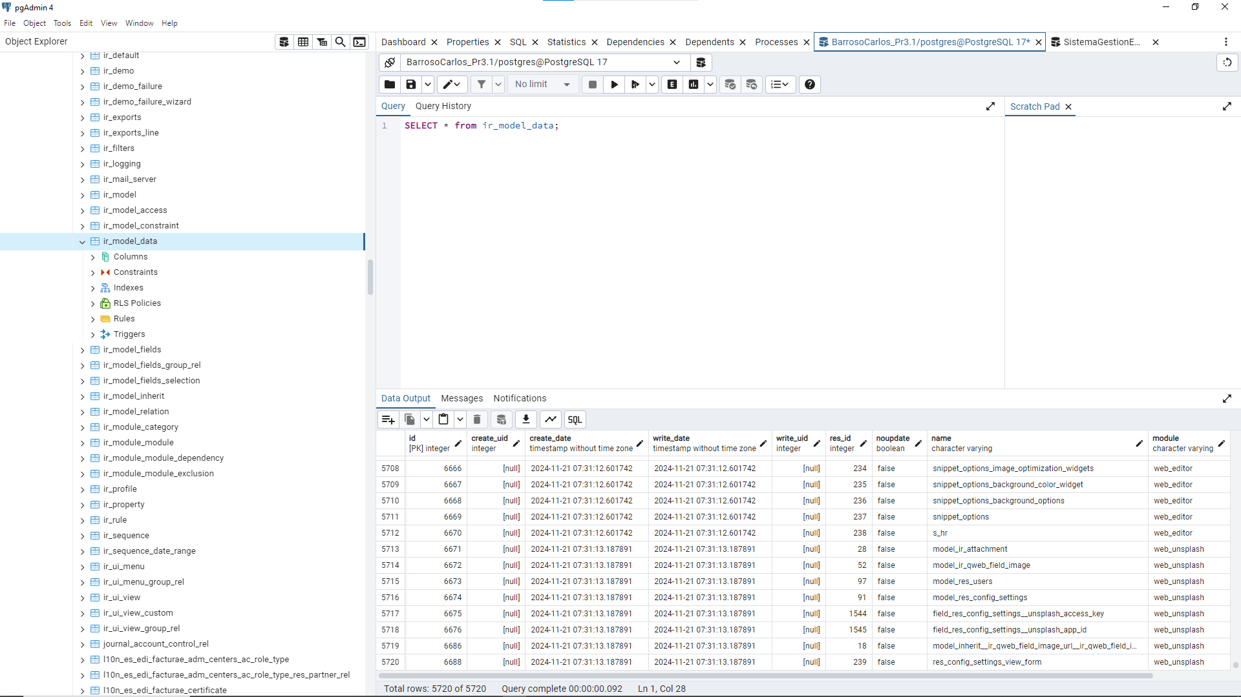

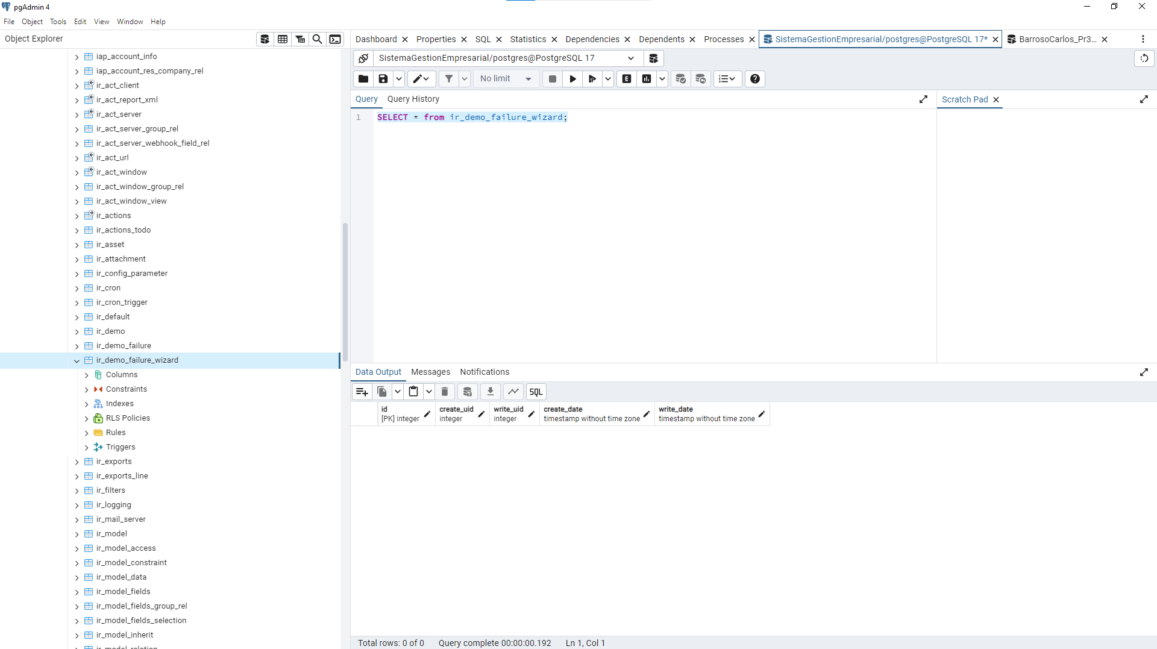
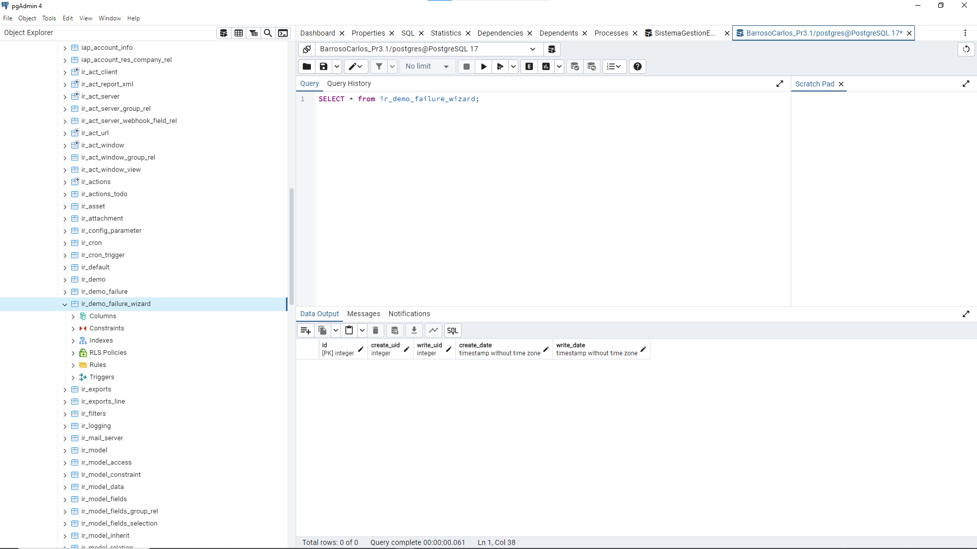
Aquí vemos la lista empleados de la taberna de moe desde odoo lo podemos ver desde el módulo de empleados
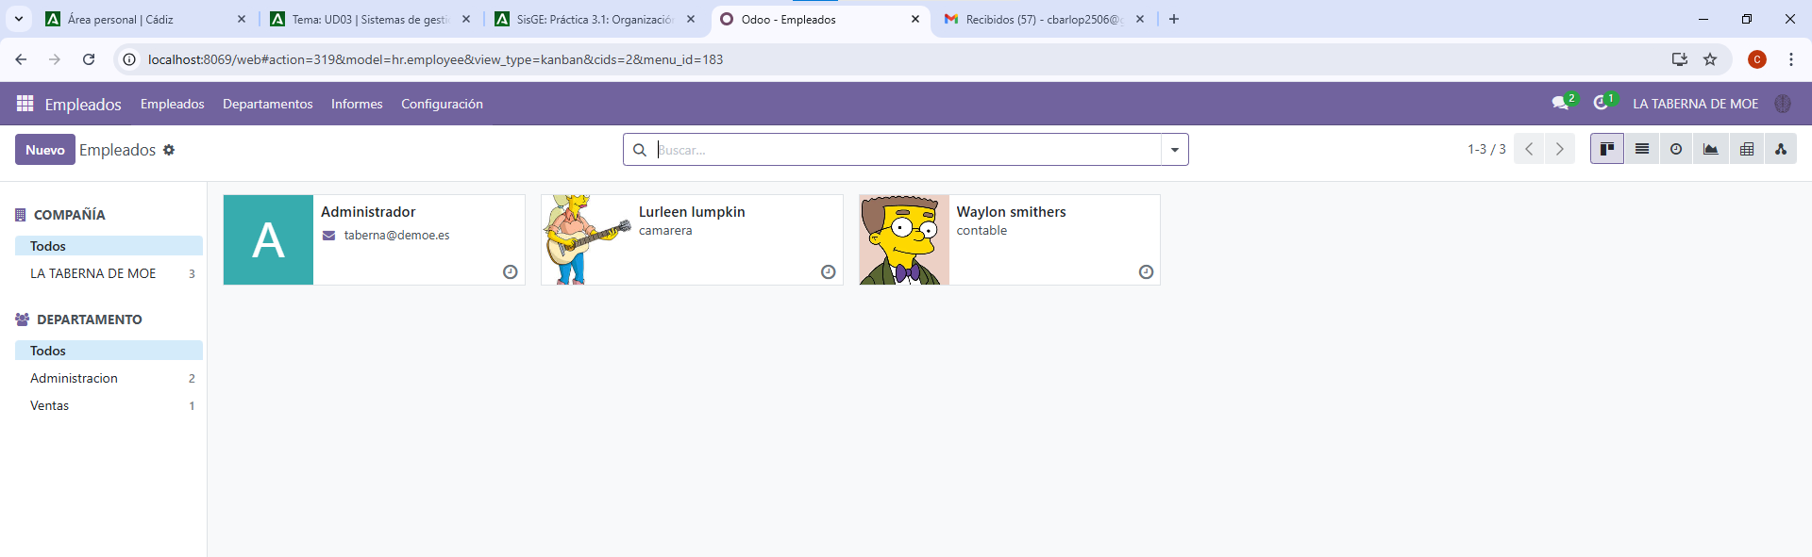

creamos un nuevo empleado en este caso con nuestros datos
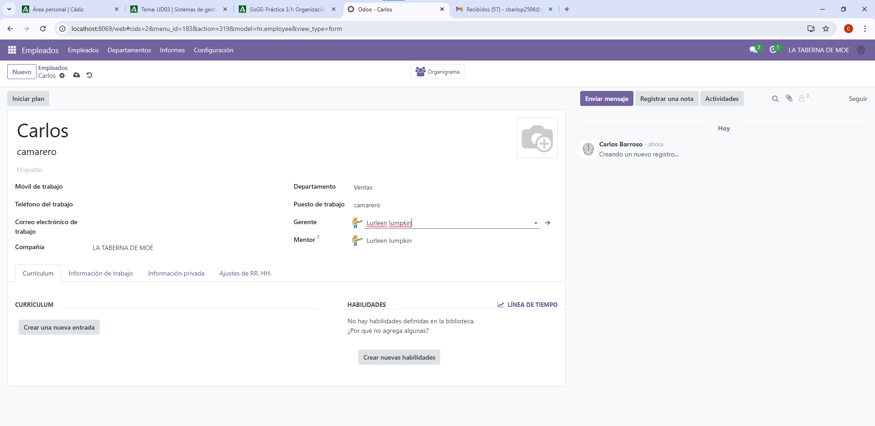
Después de guardar los datos
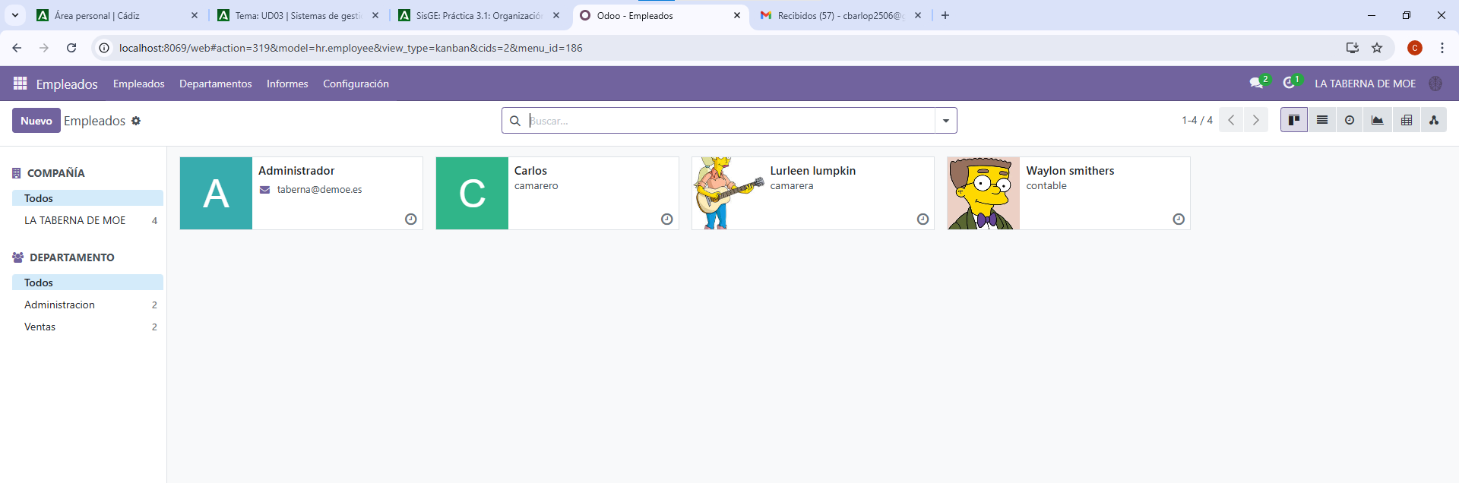

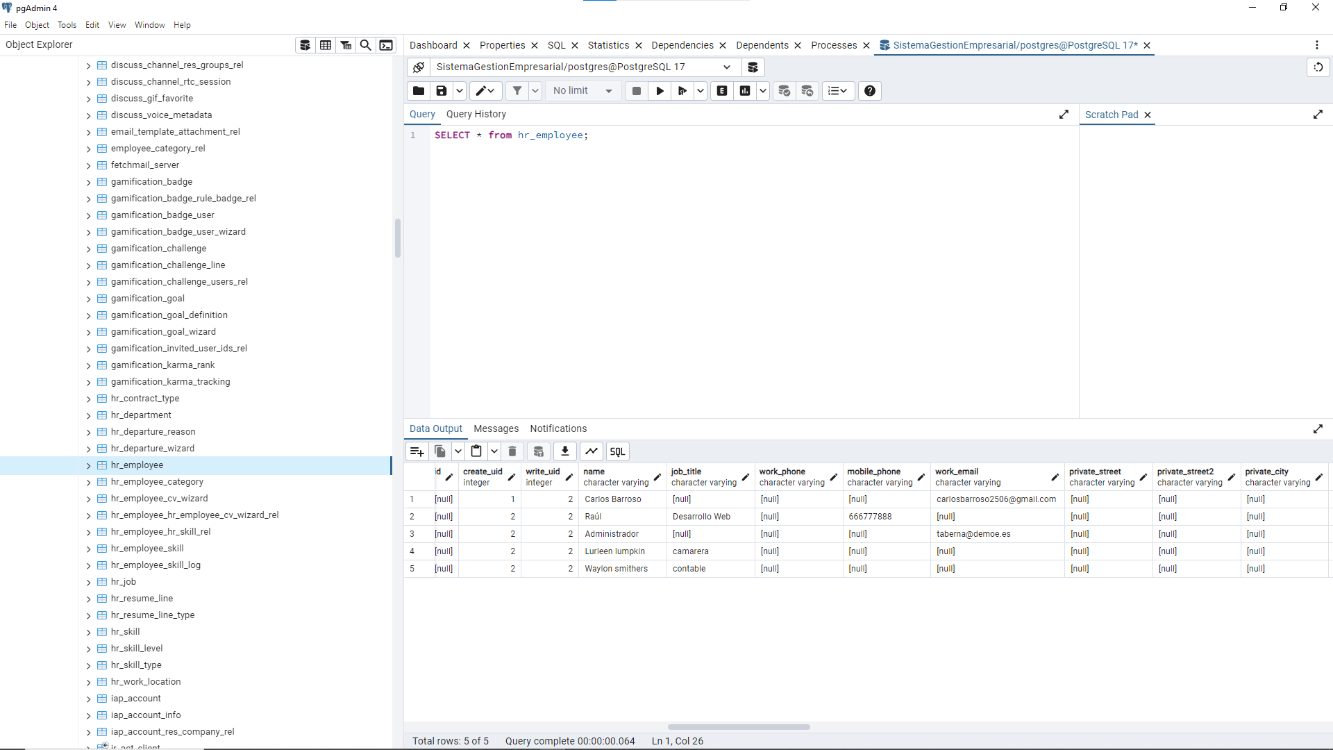

Sentencia créate:
CREATE TABLE IF NOT EXISTS public.hr_employee
(
id integer NOT NULL DEFAULT nextval('hr_employee_id_seq'::regclass),
resource_id integer NOT NULL,
company_id integer NOT NULL,
resource_calendar_id integer,
message_main_attachment_id integer,
color integer,
department_id integer,
job_id integer,
address_id integer,
work_contact_id integer,
work_location_id integer,
user_id integer,
parent_id integer,
coach_id integer,
private_state_id integer,
private_country_id integer,
country_id integer,
children integer,
country_of_birth integer,
bank_account_id integer,
km_home_work integer,
departure_reason_id integer,
create_uid integer,
write_uid integer,
name character varying COLLATE pg_catalog."default",
job_title character varying COLLATE pg_catalog."default",
work_phone character varying COLLATE pg_catalog."default",
mobile_phone character varying COLLATE pg_catalog."default",
work_email character varying COLLATE pg_catalog."default",
private_street character varying COLLATE pg_catalog."default",
private_street2 character varying COLLATE pg_catalog."default",
private_city character varying COLLATE pg_catalog."default",
private_zip character varying COLLATE pg_catalog."default",
private_phone character varying COLLATE pg_catalog."default",
private_email character varying COLLATE pg_catalog."default",
lang character varying COLLATE pg_catalog."default",
gender character varying COLLATE pg_catalog."default",
marital character varying COLLATE pg_catalog."default",
spouse_complete_name character varying COLLATE pg_catalog."default",
place_of_birth character varying COLLATE pg_catalog."default",
ssnid character varying COLLATE pg_catalog."default",
sinid character varying COLLATE pg_catalog."default",
identification_id character varying COLLATE pg_catalog."default",
passport_id character varying COLLATE pg_catalog."default",
permit_no character varying COLLATE pg_catalog."default",
visa_no character varying COLLATE pg_catalog."default",
certificate character varying COLLATE pg_catalog."default",
study_field character varying COLLATE pg_catalog."default",
study_school character varying COLLATE pg_catalog."default",
emergency_contact character varying COLLATE pg_catalog."default",
emergency_phone character varying COLLATE pg_catalog."default",
employee_type character varying COLLATE pg_catalog."default" NOT NULL,
barcode character varying COLLATE pg_catalog."default",
pin character varying COLLATE pg_catalog."default",
private_car_plate character varying COLLATE pg_catalog."default",
spouse_birthdate date,
birthday date,
visa_expire date,
work_permit_expiration_date date,
departure_date date,
employee_properties jsonb,
additional_note text COLLATE pg_catalog."default",
notes text COLLATE pg_catalog."default",
departure_description text COLLATE pg_catalog."default",
active boolean,
work_permit_scheduled_activity boolean,
create_date timestamp without time zone,
write_date timestamp without time zone,
CONSTRAINT hr_employee_pkey PRIMARY KEY (id),
CONSTRAINT hr_employee_barcode_uniq UNIQUE (barcode),
CONSTRAINT hr_employee_user_uniq UNIQUE (user_id, company_id),
CONSTRAINT hr_employee_address_id_fkey FOREIGN KEY (address_id)
REFERENCES public.res_partner (id) MATCH SIMPLE
ON UPDATE NO ACTION
ON DELETE SET NULL,
CONSTRAINT hr_employee_bank_account_id_fkey FOREIGN KEY (bank_account_id)
REFERENCES public.res_partner_bank (id) MATCH SIMPLE
ON UPDATE NO ACTION
ON DELETE SET NULL,
CONSTRAINT hr_employee_coach_id_fkey FOREIGN KEY (coach_id)
REFERENCES public.hr_employee (id) MATCH SIMPLE
ON UPDATE NO ACTION
ON DELETE SET NULL,
CONSTRAINT hr_employee_company_id_fkey FOREIGN KEY (company_id)
REFERENCES public.res_company (id) MATCH SIMPLE
ON UPDATE NO ACTION
ON DELETE SET NULL,
CONSTRAINT hr_employee_country_id_fkey FOREIGN KEY (country_id)
REFERENCES public.res_country (id) MATCH SIMPLE
ON UPDATE NO ACTION
ON DELETE SET NULL,
CONSTRAINT hr_employee_country_of_birth_fkey FOREIGN KEY (country_of_birth)
REFERENCES public.res_country (id) MATCH SIMPLE
ON UPDATE NO ACTION
ON DELETE SET NULL,
CONSTRAINT hr_employee_create_uid_fkey FOREIGN KEY (create_uid)
REFERENCES public.res_users (id) MATCH SIMPLE
ON UPDATE NO ACTION
ON DELETE SET NULL,
CONSTRAINT hr_employee_department_id_fkey FOREIGN KEY (department_id)
REFERENCES public.hr_department (id) MATCH SIMPLE
ON UPDATE NO ACTION
ON DELETE SET NULL,
CONSTRAINT hr_employee_departure_reason_id_fkey FOREIGN KEY (departure_reason_id)
REFERENCES public.hr_departure_reason (id) MATCH SIMPLE
ON UPDATE NO ACTION
ON DELETE RESTRICT,
CONSTRAINT hr_employee_job_id_fkey FOREIGN KEY (job_id)
REFERENCES public.hr_job (id) MATCH SIMPLE
ON UPDATE NO ACTION
ON DELETE SET NULL,
CONSTRAINT hr_employee_message_main_attachment_id_fkey FOREIGN KEY (message_main_attachment_id)
REFERENCES public.ir_attachment (id) MATCH SIMPLE
ON UPDATE NO ACTION
ON DELETE SET NULL,
CONSTRAINT hr_employee_parent_id_fkey FOREIGN KEY (parent_id)
REFERENCES public.hr_employee (id) MATCH SIMPLE
ON UPDATE NO ACTION
ON DELETE SET NULL,
CONSTRAINT hr_employee_private_country_id_fkey FOREIGN KEY (private_country_id)
REFERENCES public.res_country (id) MATCH SIMPLE
ON UPDATE NO ACTION
ON DELETE SET NULL,
CONSTRAINT hr_employee_private_state_id_fkey FOREIGN KEY (private_state_id)
REFERENCES public.res_country_state (id) MATCH SIMPLE
ON UPDATE NO ACTION
ON DELETE SET NULL,
CONSTRAINT hr_employee_resource_calendar_id_fkey FOREIGN KEY (resource_calendar_id)
REFERENCES public.resource_calendar (id) MATCH SIMPLE
ON UPDATE NO ACTION
ON DELETE SET NULL,
CONSTRAINT hr_employee_resource_id_fkey FOREIGN KEY (resource_id)
REFERENCES public.resource_resource (id) MATCH SIMPLE
ON UPDATE NO ACTION
ON DELETE RESTRICT,
CONSTRAINT hr_employee_user_id_fkey FOREIGN KEY (user_id)
REFERENCES public.res_users (id) MATCH SIMPLE
ON UPDATE NO ACTION
ON DELETE RESTRICT,
CONSTRAINT hr_employee_work_contact_id_fkey FOREIGN KEY (work_contact_id)
REFERENCES public.res_partner (id) MATCH SIMPLE
ON UPDATE NO ACTION
ON DELETE SET NULL,
CONSTRAINT hr_employee_work_location_id_fkey FOREIGN KEY (work_location_id)
REFERENCES public.hr_work_location (id) MATCH SIMPLE
ON UPDATE NO ACTION
ON DELETE SET NULL,
CONSTRAINT hr_employee_write_uid_fkey FOREIGN KEY (write_uid)
REFERENCES public.res_users (id) MATCH SIMPLE
ON UPDATE NO ACTION
ON DELETE SET NULL
)

